**P2 – Explain the impact of introducing an e-commerce system to an organisation.**

**Introduction**

In this report, I will explain the impact of introducing an e-commerce to an organisation. This means, I will explain the benefits and drawbacks of it.

* Benefits: e.g. global marketplace, 24/7 trading, relatively low start-up and running costs, competitive edge, search facilities, gathering customer information, alternative income sources, pricing opportunities e.g. differences, fluid pricing
* Drawbacks: e.g. consumer trust, lack of human contact, delivery issues, international legislation, product description problems, security issues

**Benefits**

**-Relatively low start-up**

Starting up an e-commerce website is relatively low comparing to a real business. All you need to do is create a website and promote your website for the customers to purchase a product. Comparing it to an organisation, this is very cheap. This is because they have to pay all the bills, stock, and gain customers. This can be hard to maintain. The costs that is used for this is to register the domain, around £5.50 per year; and the largest expense is to design and construct, which is around £500.

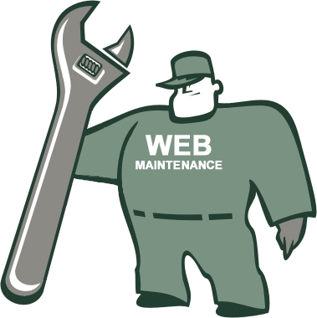

**Running costs**

Running costs is relatively low. It is similar to starting-up the business. Some examples of what an e-commerce organisation would have to do is the domain registration, money transfer services, hosting a website online would need to be at a cost – this costs around £5 – and lastly it is security. An annual charge is around £50 to encryption (secures it as a password) of data.

**Competitive edge**

Competitive edge is important in the e-commerce world. Some users find it easy to order stuff online, and it is cheaper. All they need to do is ‘add to cart’ and pay for it. This gives a competitive advantage by the user gaining more customers simply because it is easy and cheaper than it is in store. For example, if I were to get a book of Amazon, it would be around £3 and if I checked at Waterstones, it would be around £10. The better option would obviously be Amazon. In addition, you can either focus on one thing, or vary your products. It does not need to be focused on one particular subject like retail stores do.

**24/7 Trading**

This is the important out of all. The benefit for this is that the user can view the website whenever he/she wants to. As stores have limits to when they can trade, e-commerce websites do not need to do that. Once they publish the website and put it online, they can keep purchasing as long as they want and whenever they want. This goes to anyone viewing it, not only in the area, but worldwide.

**Drawbacks**

**Lack of human contact & Customer Trust**

This drawback is important, because you do not know who they are. One of the main threat could be gaming. If a 12 year old wants an 18+ game, but cannot purchase it in store. He will go online and purchase it. This could add more side effects on the 12-year-old kid buying the game. You cannot trust the customers of how they will use the specific item. If they had a cream, and they were using it the wrong way, they want a refund; the e-commerce website cannot do anything, because they should have read the instructions properly. Things like this could cause chaos. The image shows exactly how the process works. Some customers cannot trust buying things online. They feel that they have to purchase on a store for them to feel secure about the item.

**Delivery issues**

Delivery issues could be another factor. One main threat could be the way it is received. One of the threat is that the item could be damaged. This could result in the company losing customers of how poorly they received their product. Another threat could be how long they take to deliver the item. It normally says, “3-5 working days”. This could frustrate the customer and they might not place another order due to how long they take.

**Product description issues**

Product description issues could be another factor. If one customer just purchased the item without reading the description, they would be unhappy if they find out the result of the item. For example, if the item says that, “it is used with few scratches”. Without the person reading it, it would cause problems with the company. The image shows how frustrated the customers could be sometimes if they do not know the outcome of the product.

**Conclusion**

As discussed, some of these factors need to be considered for Tick Tock. Some of these threats could result in this business losing customers. However, if the techniques are used right and the business avoids to use the drawbacks, they can gain customers immediately. It takes a bit of time for the customers to gain customer trust, but they can gain the trust by the quality of the product, and offering special discount for the customers. Some of the threats could be made by viruses. However, these potential risks could be faced whenever, and when alerted, it should be removed immediately. Scanning an anti-virus software could remove the viruses, but not all. Some of the users need to be aware of what sites they browse. This is, because some sites are not safe for the user, nor computer, to use.